SUNNY D’SOUZA
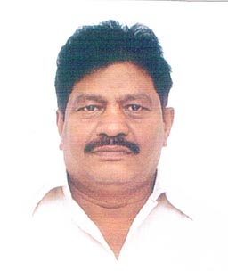

Objective : To serve as Trainee Assistant Driller / Derrickman in Drilling Rigs

Address : E/6, Nirmala Colony
St. John Baptist Road, Bandra (West), Mumbai – 400 050
Tel : 91 – 22 – 26421044
Email ID: sunnydsouza27@gmail.com

Date & Place of Birth : 03-04-1970, Mumbai

Passport Details :

Passport No. Z3098923 Place of issue : Mumbai
Date of issue : 15-04-2015 Date of Expiry : 14-04-2025

Education : S.S.L.C.

PRESENT EMPLOYMENT :

Presently working for ALBORZ in Iran from February, 2013 till date as ASSISTANT DRILLER. (Ocean Oilfield Services)

PREVIOUS EXPERIENCE:

Worked for Nabors on the Rig 805 as Trainee AD / Derrickman from Aug., 2010 till Feb.,2013

Worked as a Trainee Assistant Driller / Derrickman on the rig ‘NOBLE DAVID TINSLEY’
from January 06 till 31st May, 2010

CDC # MT 188830 issue on 17th February 2013 valid till 16th February 2018, issue by Government of Belize

August 1999 to October 2004
Derrickman on board jack-up drilling rig Maersk Valiant of Maersk Jupiter Drilling Corporation S.A., Dubai branch at Iran offshore

March 1994 to November 1999
DERRICKMAN on board jack-up drilling rig Maersk Viking of Maersk Contractors at
Qatar Offshore.

January, 1992 to February, 1994
Derrickman on board Land Rig ADC – 7 of Arabian Drilling Co. in Saudi Arabia

June 1991 to December, 1991
Derrickman on board jack-up drilling Trident – II of Sedco Forex Schlumberger at Bombay High, India

June 1989 to June 1991
Derrickman on board jack-up drilling Rig Dual – 38 of Dual Drilling Co., at Bombay High, India.

January 1988 to May 1989
Floorman / Derrickman on board Drill Ship Rig-445 of Sedco Forex Schlumberger at Bombay High, India and Philippines Offshore.

